UNIVERSITY OF AZAD JAMMU & KASHMIR CHELLAH CAMPUS MUZAFFERABAD

DEPARTMENT OF SOFTWARE ENGINEERING

Databases Systems
(Lab Task # 01)

Submitted By:
Hasnain Malik
(2024-SE-37)

Submitted To:
Respected “Engr. Awais Rathore”

Session: 2024-2028

Database Environment Setup & Configuration (XAMPP)

- Introduction to XAMPP:
XAMPP is a free, open-source cross-platform web server solution stack. It provides a local server environment required to develop and test database-driven applications.

- Key Use Cases:
- Local testing of SQL queries before deploying to a live server.
- Developing web applications using PHP and MySQL.
- Managing databases through a user-friendly graphical interface (phpMyAdmin).
- Server Initialization & Control Panel:

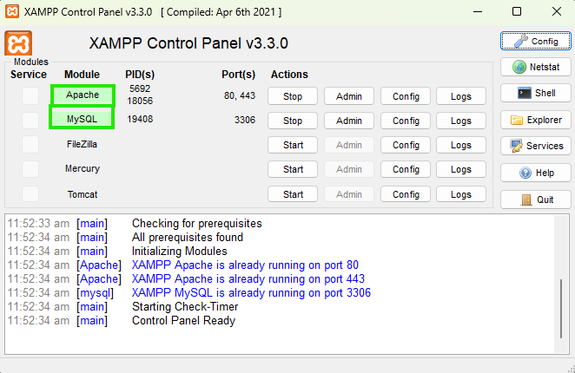

- Service Activation:
Successfully initialized the Apache and MySQL modules.
- Port Configuration:
Apache is running on default ports 80/443, while MySQL is active on port 3306.
- Status Indicators:
The green highlights in the control panel confirm that the local server environment is stable and ready for database operations.
- Module Management:
These services act as the backbone for creating and managing relational schemas throughout the lab sessions.

- Connectivity & Localhost Verification:

- URL Routing: Navigated to http://localhost/ to verify that the local Apache server is correctly intercepting requests.
- Communication Bridge: The highlighted URL confirms that the browser is communicating with the local loopback address (127.0.0.1).
- System Readiness: This step ensures that the environment is properly configured to launch the database management dashboard.

- Database Management via phpMyAdmin:

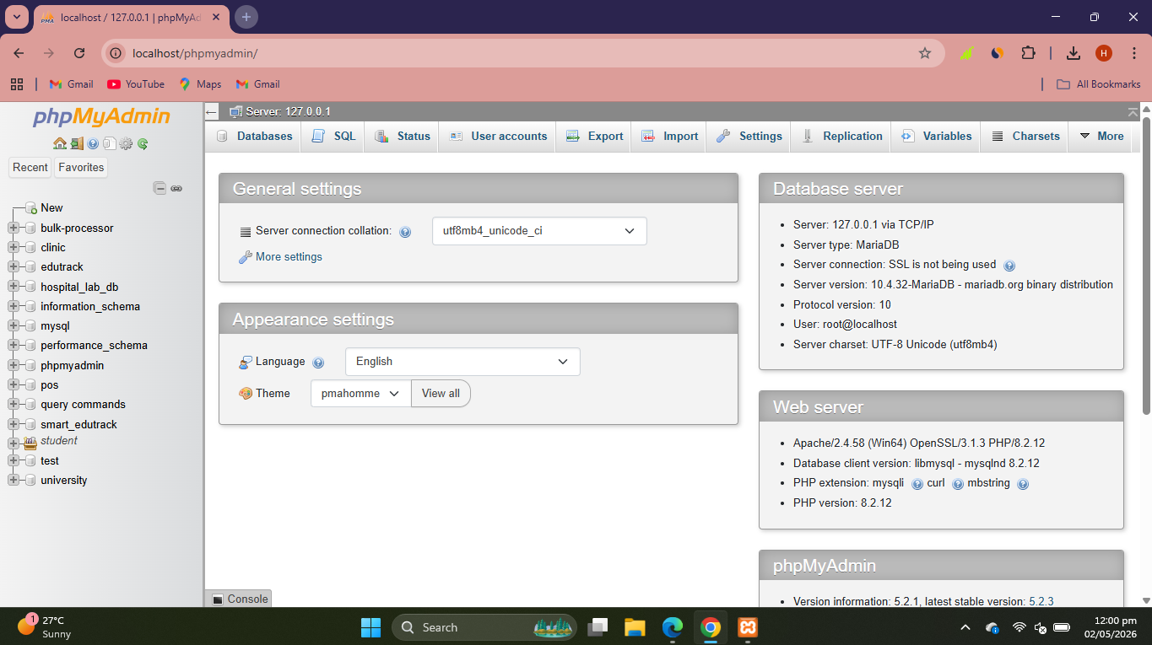
- GUI Dashboard: This interface provides a powerful web-based management tool for MySQL databases.
- Schema Navigation: The sidebar displays the existing database structures, providing a centralized view of all active projects.
- Development Ready: The availability of the SQL command editor and structure tabs indicates a fully functional environment for DDL (Data Definition Language) and DML (Data Manipulation Language) tasks.
- Project Overview: By maintaining an organized list of databases here, we ensure data integrity and ease of access for complex normalization and query tasks.

